**CURRICULUM VITAE**

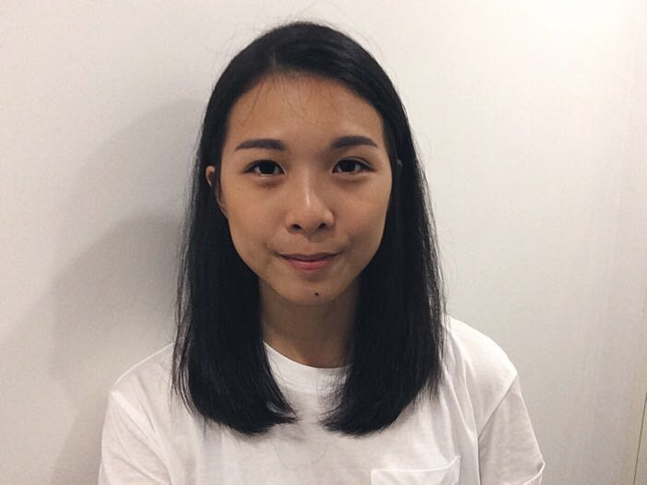

**Full Name**: VOON SUWEN (Jacey) **Gender**: Female

**NRIC**: 950925-14-5578 **Age**: 21 years old

**Nationality**: Malaysian **Marital status**: Single

**Telephone**: 010-2929216 (mobile phone)

**Email address**: [voonsuwen@gmail.com](mailto:voonsuwen@gmail.com)

**Permanent Address**: Sunstone Villa, 30, Jalan Penggawa 17/2, Seksyen 2, Bandar Mahkota Cheras, Selangor, 43200.

**QUALIFICATIONS**

**2015** **-Now** Tunku Abdul Rahman University College

Bachelor in Economics (Honours) Semester 1-3 CGPA: 2. 83

**2016** Malaysian University English Test (MUET): Band 4

**2013-2015** Tunku Abdul Rahman University College

Diploma in Business Studies (Business Economic): CGPA 3.1055

English For IELTS: A-

**2008-2012** SMK Puteri Titiwangsa

SPM Grade: 2A- 4B 1C+ 1C 1D

**Extra-curiccular activities**

**2015** Tunku Abdul Rahman University College

Softball curricular activity. Intra faculty basketball activity, inter Tarc basketball activity

**2013** Tunku Abdul Rahman College

Leader for Basketball curricular activity. Participated in Sports Day.

Member of TARUC Economic Society.

**WORK EXPERIENCE**

KL Festival city mall, Setapak

Part time promoter from October 2011 to December 2011. Sell and promote mobile phone accessories.

KOJADI, Jalan Ampang

Admin clerk from end of 2012 to April 2013. Organized Medical leaves and salary payments. Answering email and phone calls. Analyse and processing for interviews. Manage the routine administration tasks.

**LANGUAGE ABILITIES**

English, Chinese, Bahasa Malaysia (Both oral and written) Cantonese, Hokkien

**INTERESTS**

Travelling, Sports, Photography

**COMPUTER SKILLS**

Microsoft Excel, Microsoft Power Point, Microsoft Word, Econometric Views (Eviews)

Internship Duration: 4th February 2017 to 30th April 2017